* + SQL QUERIES AND THEIR OUTPUTS
* **Note:** *These are illustrative queries that were executed to on datasets and similar queries were also executed on other monthly datasets.*

1*.Query to see existing data from the table*

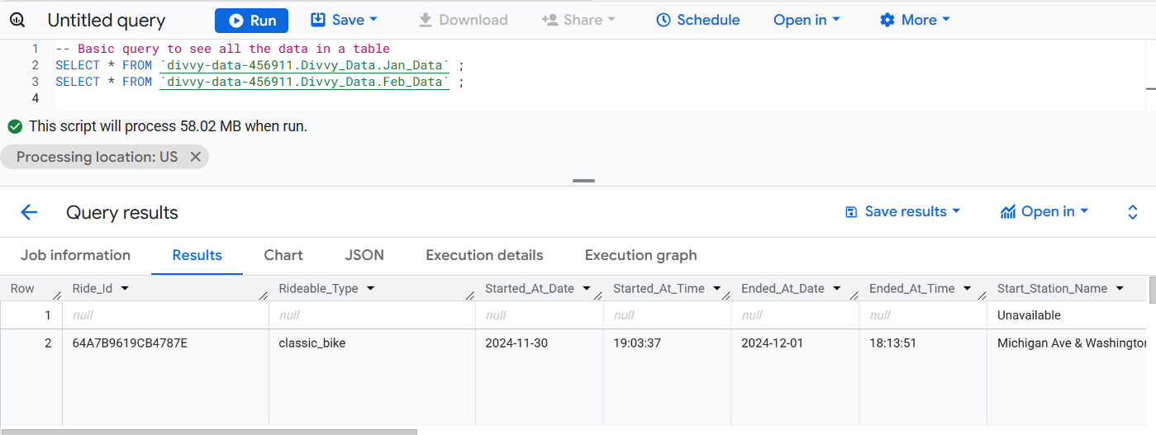

2. *Sorting Data into a logical and meaningful order*

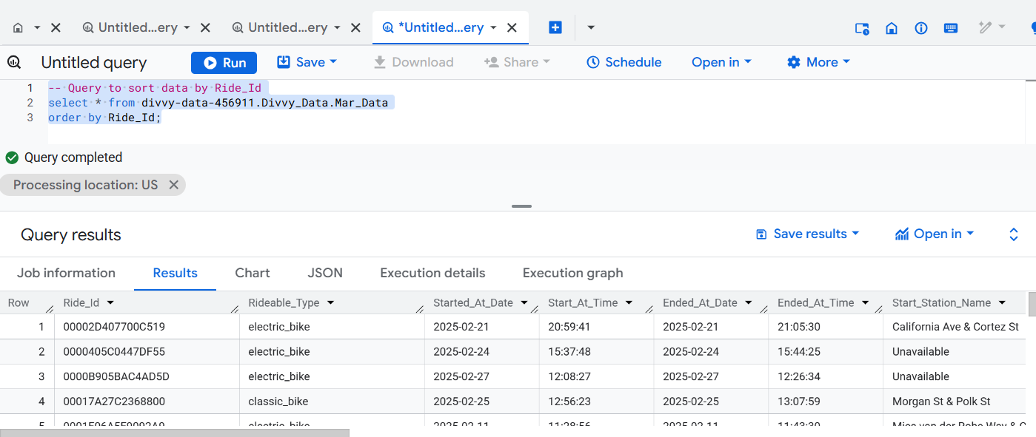

3. *Query to check the total members using electric bikes*

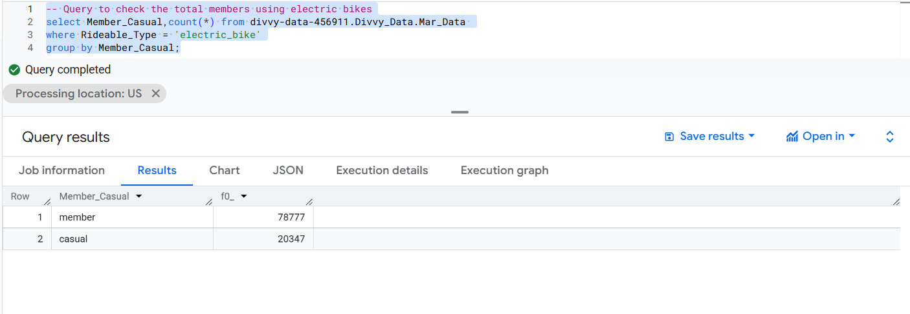

*4. Query to see total users of electric and classic bike of people with membership*

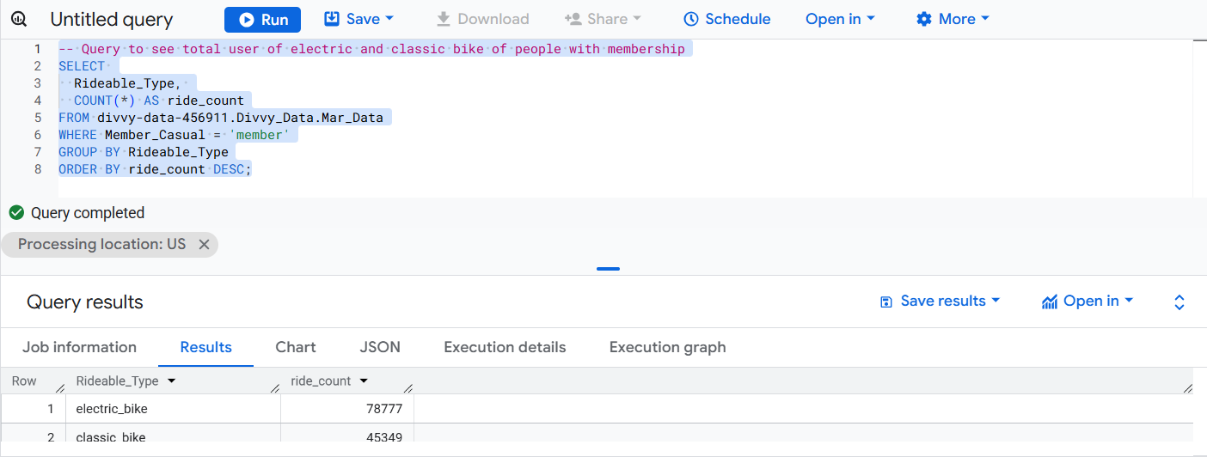

*5. Query to see total user of electric and classic bike of people with casual membership*

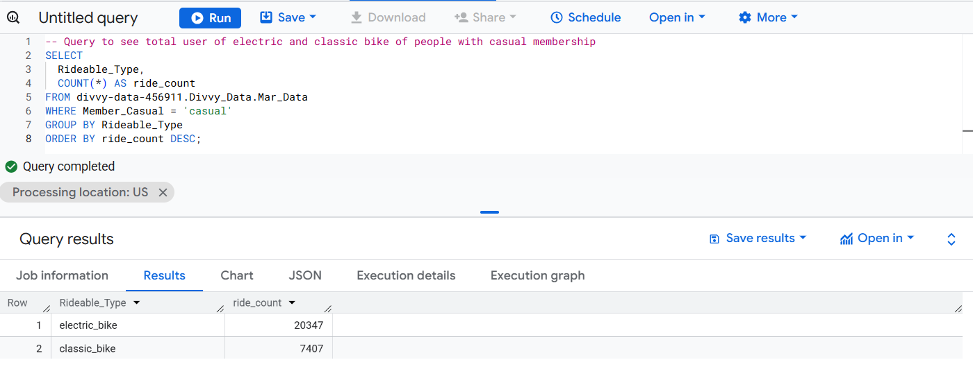

*6. Query to see the total user of electric and classic bike of people having permanent and casual memberships*

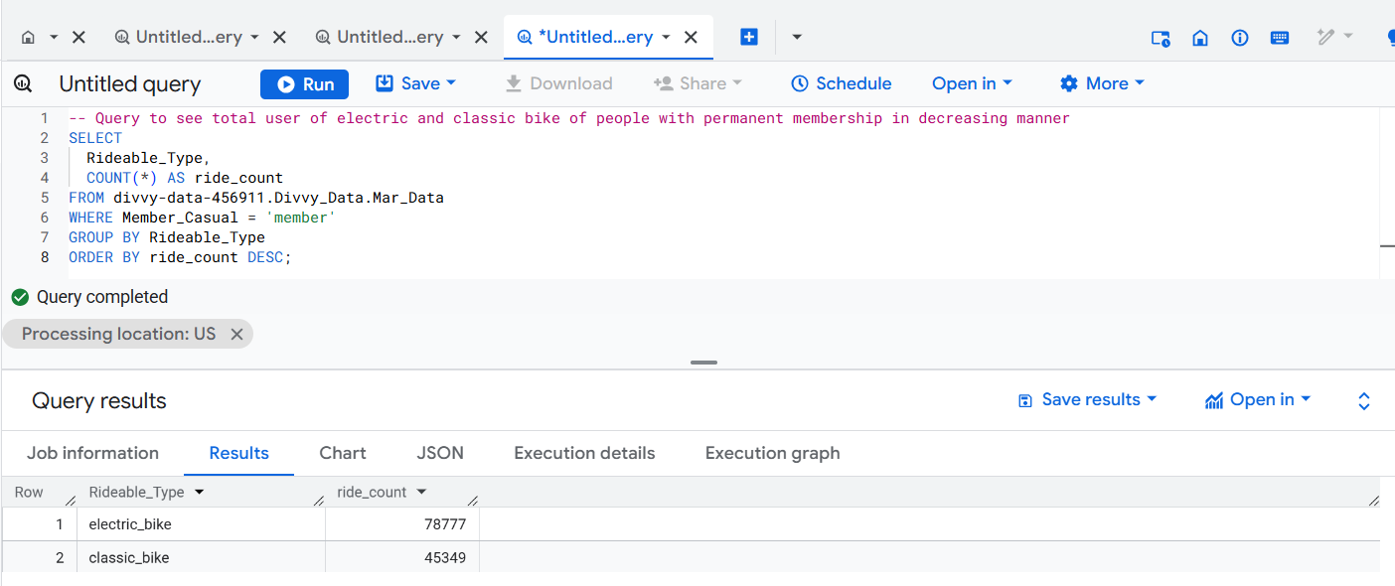

*7. Query to see the total ride according to the use of bike in a day grouped by membership types.*

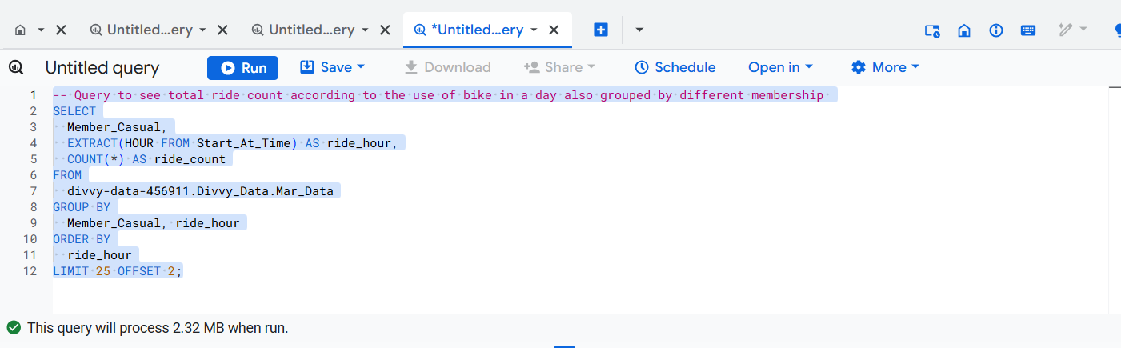

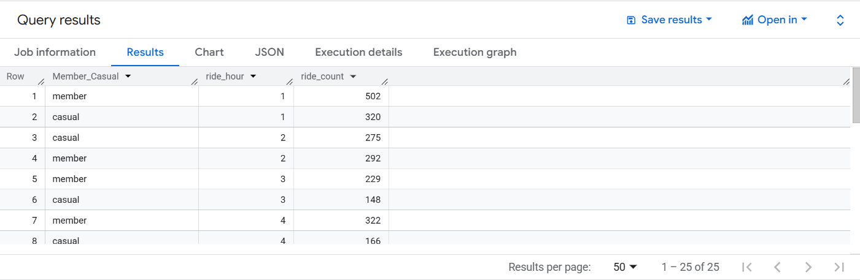

*8. Query to see most popular destination where the trip ended most of times*

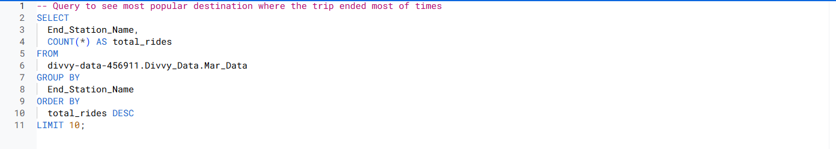

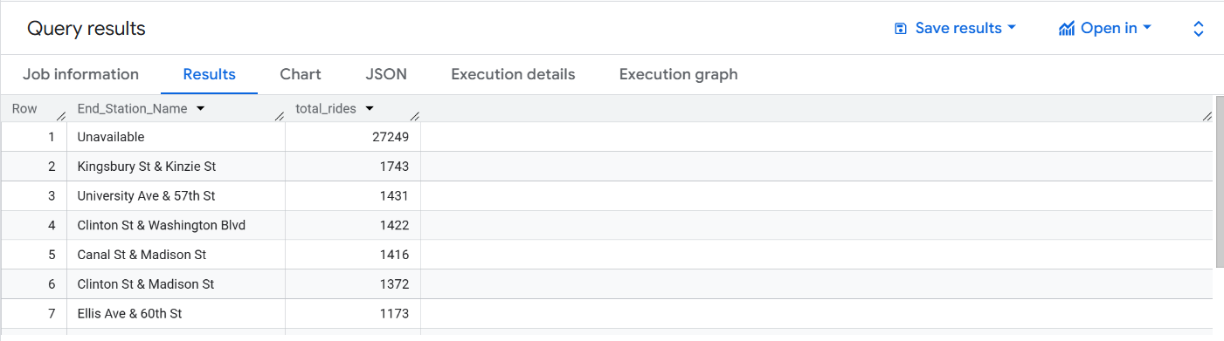

*9. Query to see total ride count for casual members and listing out most popular end stations.*



